**ADT Lab 2 (10pts)**

**Name : Atharv J**

**Q1** Correcting query and output

**Q2** Concatenating Column Values

**Q3** Case expression

**Q4** Finding and dealing with Null Values

**Q5** Searching for Patterns

**Grading criteria - Highlight the questions you are done with to green colour**

1. Install MySQL workbench (Refer- <https://www.geeksforgeeks.org/how-to-install-sql-workbench-for-mysql-on-windows/> )
2. Download emp.csv and dept.csv from Week 1 coding practice
3. Open MySQL workbench and create a new schema-
4. Click on the icon highlighted in blue which says- ‘Create a new schema in the connected server’

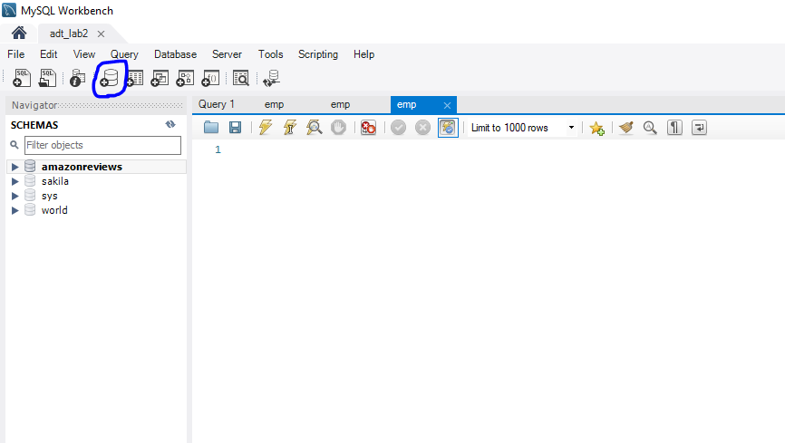

1. Specify name of the schema. Name of the schema should be your First name. Then hit Apply.
2. Now you will see SQL script to create a new schema. Click apply again to execute the script and then click finish.

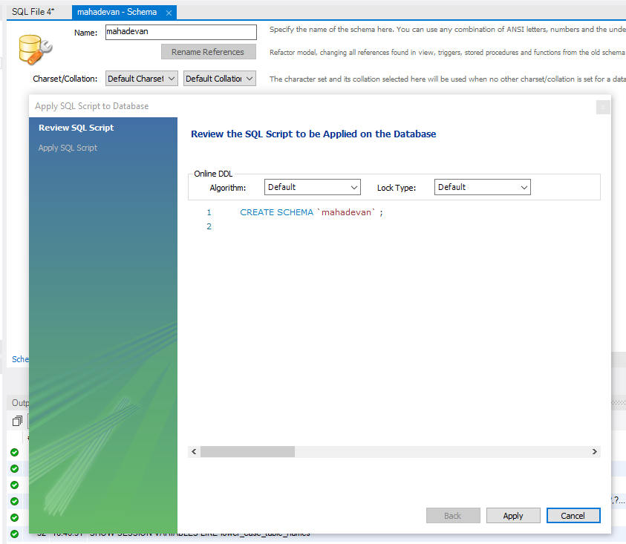

1. Now on the left pane you can see the new schema name. Double click on the schema.
2. Right click on the Tables and click Table Data Import Wizard and specify the location of emp.csv that you downloaded.

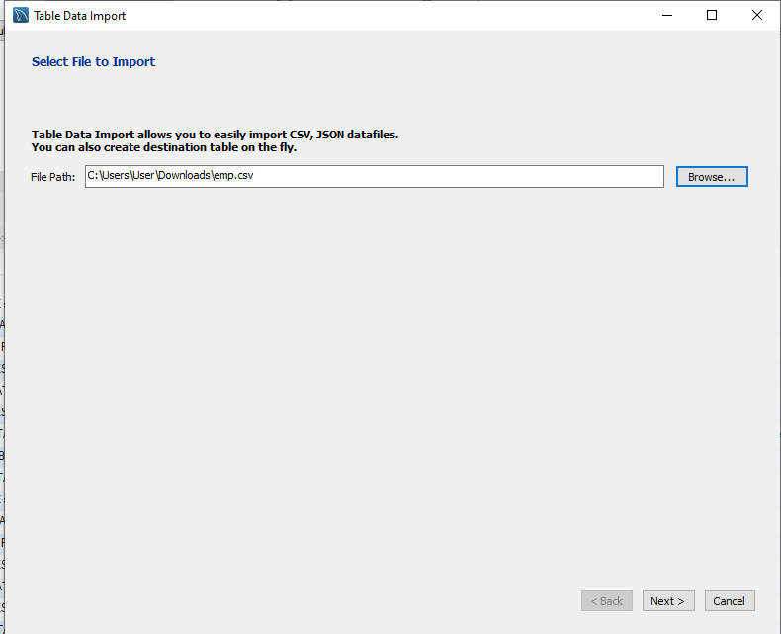

1. Change the Field Type of MGR to text instead of the default int

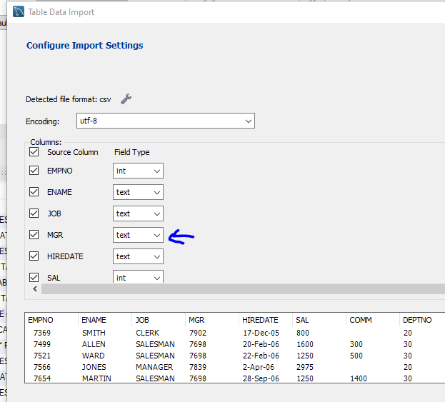

1. Now you will see that 14 records were imported and you can also see the new table under the tables dropdown once you hit refresh.
2. In the same manner create a dept table from dept.csv file

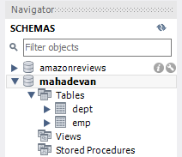

1. SQL practice on emp and dept tables-
2. Referencing an Aliased Column in the WHERE Clause

You have used aliases to provide more meaningful column names for your result set and would like to exclude some of the rows using the WHERE clause. However, your attempt to reference alias names in the WHERE clause fails

Example-

select sal as salary, comm as commission from emp where salary < 5000

Error-



Q1. Correct this query and the output.

Hint- By wrapping your query as an inline view, you can reference the aliased columns

# Paste the screen shot of your query and output

# Your schema name (which is your first name) should be visible in your screenshot

# Screenshot should also include your query and the output

Expected Output-

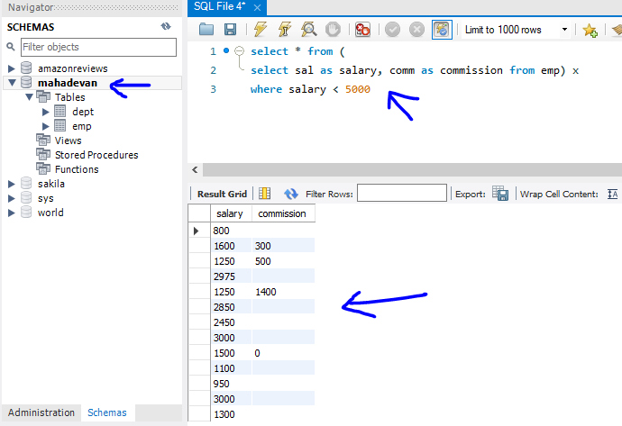

Example Answer-



Your answer-

# Paste your screenshot for Q1

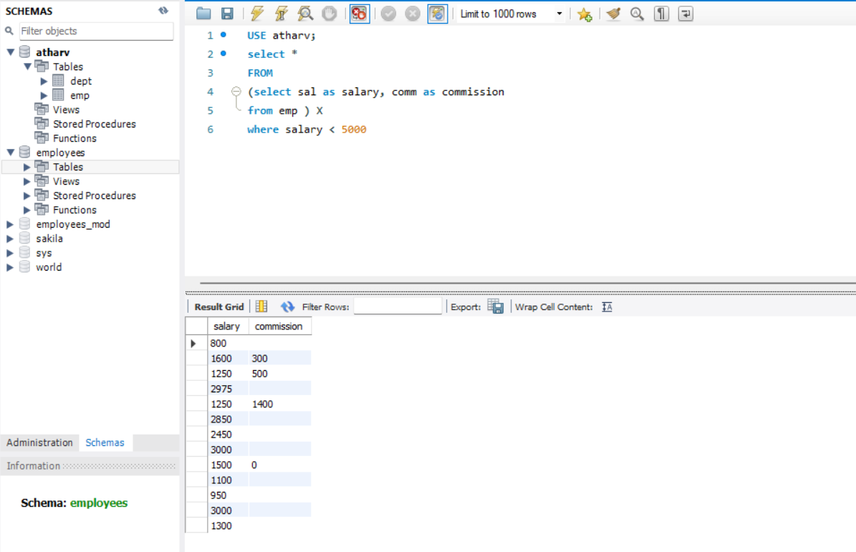

Discussion-

The WHERE clause is evaluated before the SELECT and the FROM clause is evaluated before the WHERE.

Q2. Concatenating Column Values

When you want to return values in multiple columns as one column you use concat function in MySQL

You have employee name in column ENAME, and their salary stored in the column SAL

Concatenate the ENAME and SAL columns.

Expected Output-

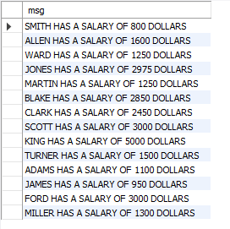

Hint- Use the CONCAT function to concatenate values from multiple columns

Your answer-

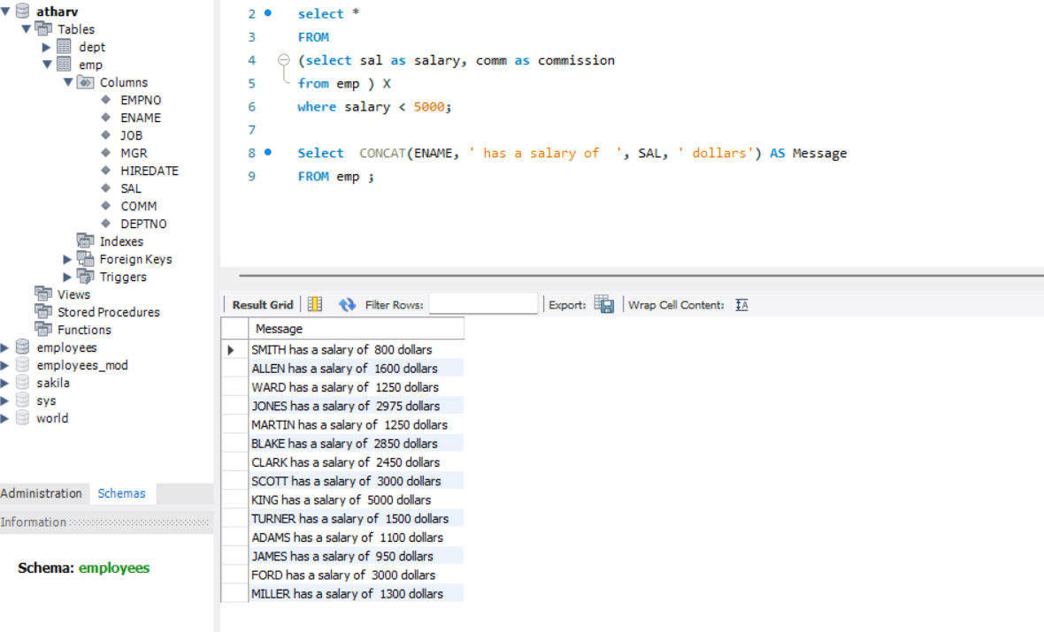

# Screenshot which includes schema name (your first name), query and result as shown before.

Q3. Case expression

When you want to perform IF-ELSE operations on values in your SELECT statement you can use case statements.

Refer- <https://www.w3schools.com/sql/sql_case.asp>

Write a query to get the pay fairness for each employee in the emp table

If employee’s salary is less than 2000 then pay_fairness will be ‘UNDERPAID’,

If its between 1000 and 4000 then pay_fairness will be ‘WELL PAID’,

If salary is greater than 4000 then pay_fairness will be ‘OVERPAID’

Else pay_fairness will be 'SALARY NOT KNOWN'

Expected Output-

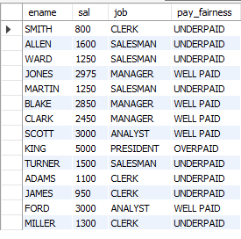

Your Answer-

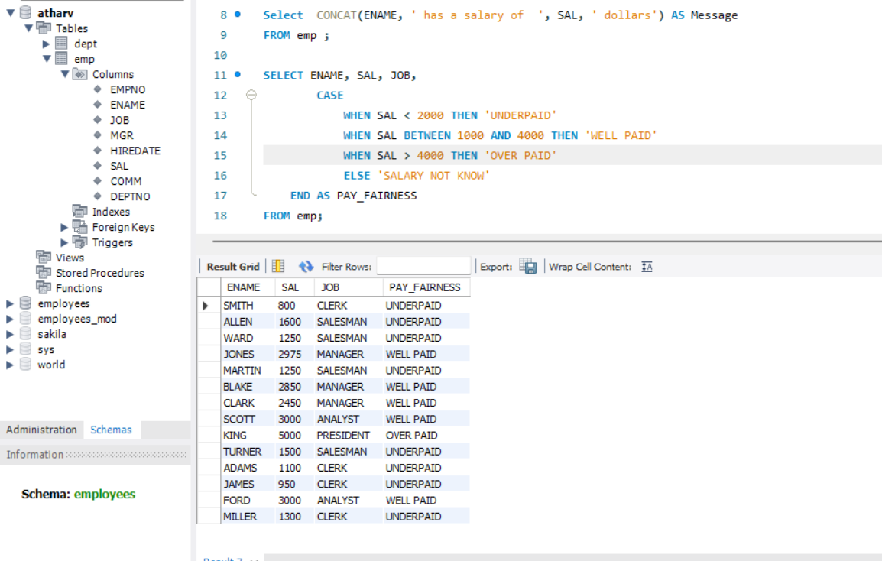

Q4 Finding and dealing with Null Values

We have 2 main inbuilt functions in MySQL to deal with null values-

COALESCE and IFNULL

We also have a function called ISNULL which checks whether an expression is null or not

Read about these 3 functions from-

ISNULL- <https://www.geeksforgeeks.org/mysql-isnull-function/?ref=lbp>

COALESCE- <https://www.geeksforgeeks.org/mysql-coalesce-function/?ref=lbp>

IFNULL- <https://www.w3schools.com/sql/func_mysql_ifnull.asp>

Use case for IFNULL and COALESCE-

<https://www.w3schools.com/sql/sql_isnull.asp> (Look under MySQL only)

Write a summary in few lines (2-3) about what you understood after reading the above articles.

Your answer-

|  |  |  |
| --- | --- | --- |
| ISNULL() | COALESCE() | IFNULL() |
| It checks if any values are  NULL or not. ISNULL returns 0 or 1 when false or true respectively. | It returns the first NOT NULL value. | It is the condition and returns the values of true or prints the message given. |
| It accepts expression as a parameter. | accepts one parameter which is the list that can contain various values | Takes a parameter and a message. |

Q5 Searching for Patterns

Read about LIKE operator- <https://www.w3schools.com/mysql/mysql_like.asp>

Get details of the employees who have the letters ‘AR’ at any position in their names (ENAME)

Expected Output-

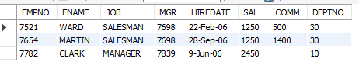

Your answer-

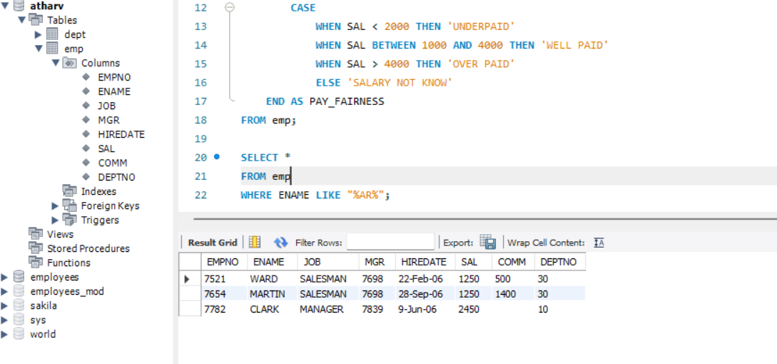

ss